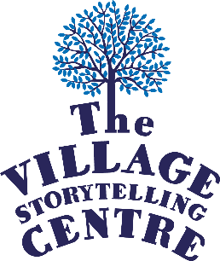
Emerging Voices in Storytelling
Application Form

Surname:

Other names:

Preferred pronouns:

Date of Birth*:

*This info is required for funding purposes

Address:

Postcode:

Email Address:

Contact Phone Number:
What is your current favourite story and why?

What does storytelling mean to you? (Max 200 words)

What would you like to gain from your Emerging Storytellers placement at The Village? (Max 300 words)

What ambitions do you have in the world of storytelling and applied storytelling? (200 words)

How would you describe your storytelling style?

Please tell us where you heard about this vacancy:

Please note: this opportunity requires a PVG Record check.

Signature:

Date:

Please return this completed form and the completed Equal Opportunities & Diversity Monitoring Form found here by 9am on Monday 3rd March 2025 to emergingvoices@villagestorytelling.org.uk

Opportunity supported by:
